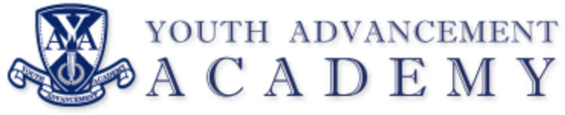

REGULAR BOARD MEETING

Oakwood Elementary
3410 Laird Ave.
Kalamazoo, MI 49008
December 10, 2024
5:30 PM

AGENDA

I. Call to Order Regular Meeting

II. Pledge of Allegiance

III. Roll Call

IV. Approval of Agenda

V. Public Comment – (five minute maximum)

VI. Approval of Minutes
November 12, 2024, Regular Meeting

VII. Communications
Director’s Report

VIII. Regular Agenda
- November Financial Report
- Management Update
- Fall Policy Update

IX. Public Comment: (non-agenda items)

X. Board Comments

XI. Adjournment

Next Meeting: January 14, 2025 @ 5:30pm (Oakwood Elementary)

